**Sennheiser introduces CX 6.00BT**

**The audio specialist debuts Bluetooth ear-canal headphones at CES 2018**

**Wedemark/Las Vegas, 8 January 2018 – At CES 2018, audio specialist Sennheiser introduces the CX 6.00BT, new Bluetooth in-ear headphones that let you enjoy brilliant sound on the go. The CX 6.00BT features ear-canal earbuds joined by a cable around the neck – a lightweight design that is compact yet robust and provides superior fit and comfort.**

Powered by Sennheiser’s high-quality proprietary speaker system, the CX 6.00BT delivers clear, detailed sound with an enhanced bass response. Thanks to Bluetooth 4.2 and Qualcomm® apt-X™, it is possible to enjoy this uncompromised wireless audio performance to the full. Qualcomm® apt-X™ Low Latency compatibility also enhances gaming or video viewing by keeping the audio transmission perfectly in sync with the visuals.

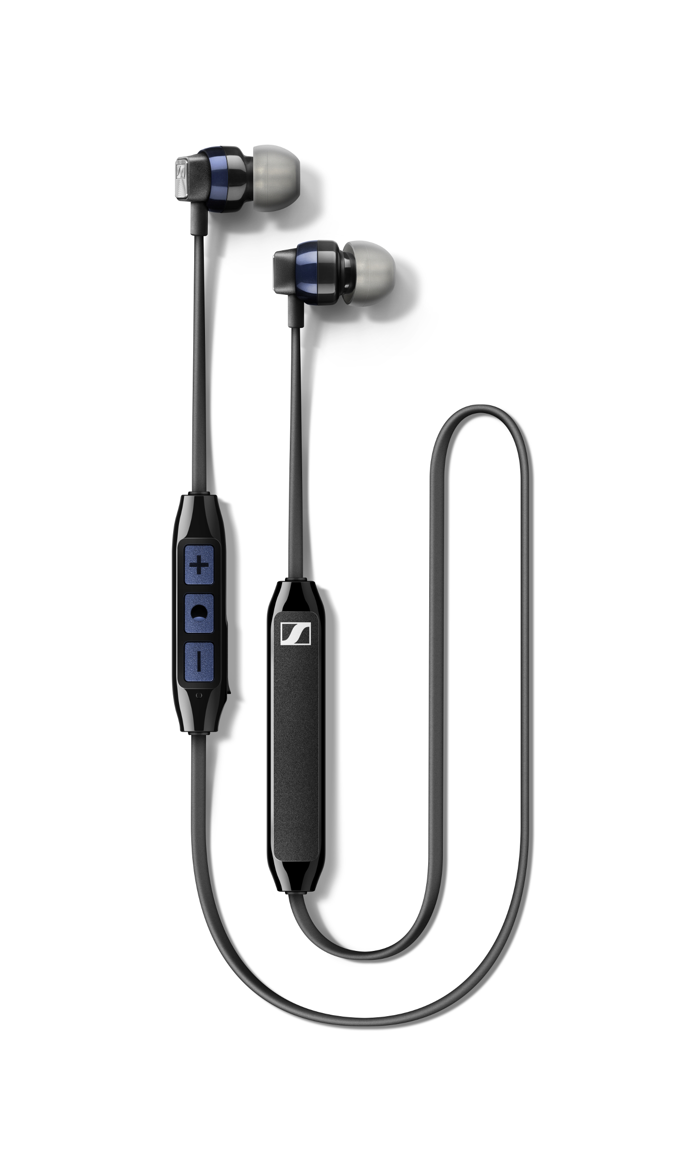

Sennheiser’s new CX 6.00BT are compact Bluetooth in-ear headphones that let you enjoy brilliant sound on the go.

“We have created the CX 6.00BT to deliver everything you need to enjoy excellent sound on the go,” said Nan Chen, Product Manager at Sennheiser. “Thanks to the latest wireless technologies you can enjoy this unspoilt audio experience with the flexibility of supremely compact, lightweight and comfortable Bluetooth headphones.”

**A lightweight design with heavyweight features**

The headphones’ features include convenient multi-connection capability that enables pairing with up to two devices simultaneously, for example when switching between one’s phone and computer. The CX 6.00BT has an integrated microphone with cVc noise cancellation technology for crystal clear calls on the go and supports 3-way calling. Alongside a three-button remote for controlling music and calls, the headphones provide convenient voice prompts notifying the user of battery status.

The CX 6.00BT also delivers superior comfort and security: Sennheiser has created an around-the-neck cable design that balances and minimizes the weight of the angled ergonomic earpieces to ensure that they stay in place. For an optimized fit, it features a cable divider for better adjustment and comes provided with a choice of four sizes of ear adapters to ensure excellent attenuation of ambient noise. Despite its feather-light 14g weight, it is tough enough to take anywhere, thanks to its robust build quality and durable materials.

With a six-hour battery life, the CX 6.00BT has been designed to complement busy lifestyles, with convenient fast charging via USB that can add two hours of battery time in just ten minutes and can be fully charged in only 1.5 hours.

The new CX 6.00BT will be available from January 2018 for 99 EUR/99.95 USD (MSRP).

CES 2018 takes place in Las Vegas from January 9-12. To experience and learn more about   
CX 6.00BT and other product news, visit Sennheiser in South Hall 1, Booth 20606.

**About Sennheiser**

Sennheiser is shaping the future of audio – a vision built on more than 70 years of innovation culture, which is deeply rooted within the company. Founded in 1945, Sennheiser remains family-owned and is today one of the world’s leading manufacturers of headphones, microphones and wireless transmission systems. With 20 sales subsidiaries and long-established trading partners, the company is active in more than 50 countries and operates its own production facilities in Germany, Ireland and the USA. Sennheiser has around 2,800 employees around the world that share a passion for audio. Since 2013, Sennheiser has been managed by Daniel Sennheiser and Dr. Andreas Sennheiser, the third generation of the family to run the company. In 2016, the Sennheiser Group had sales totaling 658.4 million. www.sennheiser.com

**Global Press Contact Press Contact USA & Canada**

Jacqueline Gusmag Jeff Touzeau

Phone: +49 (0)5130 600-1540 Phone: +1 914 602 2913

[jacqueline.gusmag@sennheiser.com](mailto:jacqueline.gusmag@sennheiser.com) jeff@hummingbirdmedia.com